**BUSINESS FORECASTING ASSIGNMENT (In R – With Script)**

|  |  |
| --- | --- |
| Q1 | Plot NAV vs Month (2 Mark) |
| Q2 | Does the time series have Irregular component? (2 Mark) |
| Q3 | Does the time series have trend? If yes, increasing or decreasing? (2 Mark) |
| Q4 | Does the time series have seasonality? If yes, at what is the period? (2 Mark) |
| Q5 | Which methods can be used for forecasting the given time series? (2 Mark) |
| Q6 | Using “Naïve” model, forecast prices for July 2010 to December 2010. Find Mean Error (ME), Mean Absolute Error (MAE) and MAPE (Mean Absolute Percentage Error) using last 6 months data (4 Mark) |
| Q7 | Using "3 Month Moving Average" model, forecast prices for July 2010 to December 2010. Find Mean Error (ME), Mean Absolute Error (MAE) and MAPE (Mean Absolute Percentage Error) using last 6 months data (4 Mark) |
| Q8 | What will be the forecast for January 2011 using Naïve Model as well as 3 Months Moving Average Model? Which one will you use in practise (2 Mark) |

Answers:

**A1:** NAV v/s Month Plot

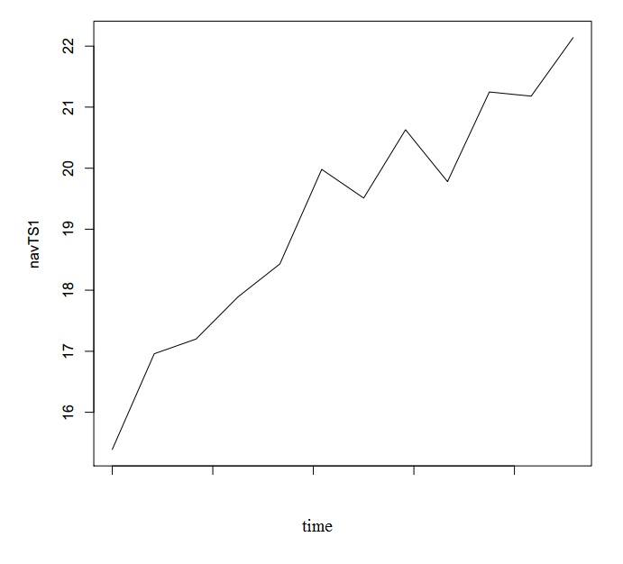

**A2:**

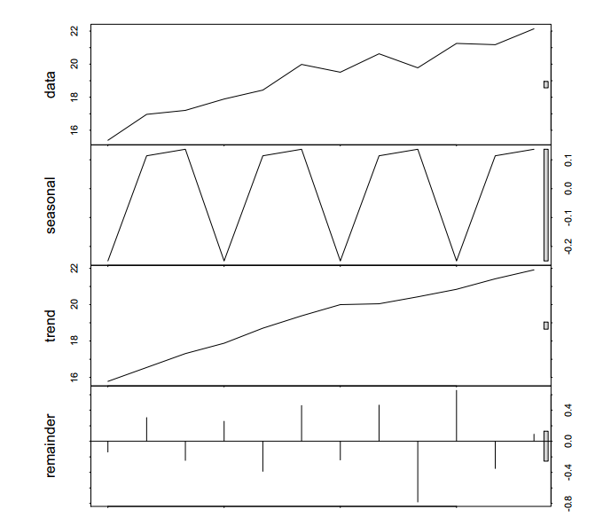

Seasonal Trend Irregular

2010.1 -0.2500340 15.77817 -0.13813341

2010.2 0.1136604 16.54162 0.30472118

2010.3 0.1363660 17.30960 -0.24596487

2010.4 -0.2500340 17.88233 0.25770588

2010.5 0.1136604 18.70314 -0.38680072

2010.6 0.1363660 19.38241 0.46122174

2010.7 -0.2500340 20.00051 -0.24047191

2010.8 0.1136604 20.04994 0.46640222

2010.9 0.1363660 20.42500 -0.78136627

2010.10 -0.2500340 20.84435 0.65568171

2010.11 0.1136604 21.41660 -0.35026494

2010.12 0.1363660 21.91246 0.09117544

According to Decomposition of the graph using stl() in R into the 3 components, It is seen that the Time Series doesn’t have a significant Seasonal or Irregular Compnonent.

Hence, the answer is that The Time Series doesn’t have a significant Irregular component.

**A3.**

From the above graph and data, it can be seen that the trend values seem significant, ranging in the graph from 16 to 22 in magnitude and their data points are reflected in the given data for each month. Hence, the Time Series DOES HAVE a Trend. And from the graph, it can be safely said that the trend is INCREASING.

**A4.**

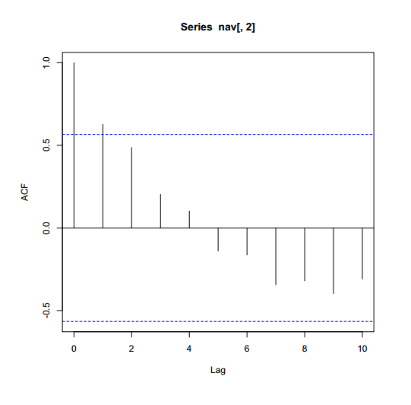

According to the ACF graph, the values seem to be gradually decreasing and there is no local maxima.

This clearly shows that there is NO SEASONALITY.

**A5.** The methods that can be used for forecasting are The Naïve model NF1, Moving average Model and Holt Method.

**A6.**

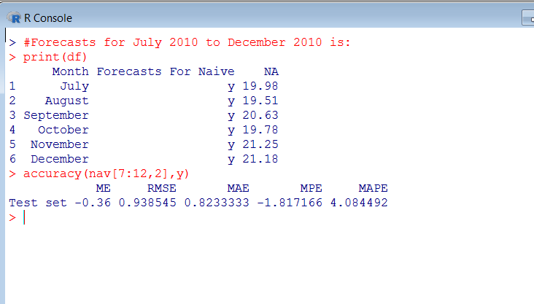

**A7.**

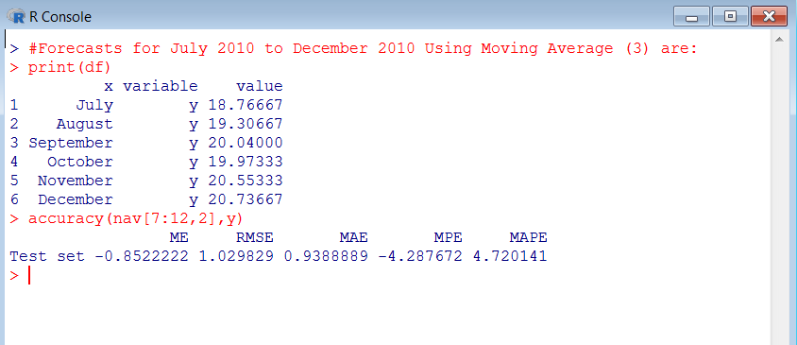

**A8.**

